**LAB 05:**

AIM: Sort a given set of N integer elements using Selection Sort technique and compute its time taken.

**ALGORITHM** : sel_sort(a[0….n-1]

//Sorts a given array by selection sort

//Input : An array a[0….n-1] of orderable elements

//Output : Array a[0….n-1] sorted in ascending order

for i←0 to n-2 do

small_pos←i

for j←i+1 to n-1 do

if a[j]&lt;a[small_pos]

small_pos←j

end if

end for

swap a[i] and a[small_pos]

end for

**Program:**

#include&lt;stdio.h&gt;

#include&lt;time.h&gt;

#include&lt;stdlib.h&gt; /* To recognise exit function when compiling with gcc*/

void selsort(int n,int a[]);

void main()

{

int a[15000],n,i,j,ch,temp;

clock_t start,end;

while(1)

{

printf(&quot;\n1:For manual entry of N value and array elements&quot;);

printf(&quot;\n2:To display time taken for sorting number of elements N in the range 500 to 14500&quot;);

printf(&quot;\n3:To exit&quot;);

printf(&quot;\nEnter your choice:&quot;);

scanf(&quot;%d&quot;, &amp;ch);

switch(ch)

{

case 1: printf(&quot;\nEnter the number of elements: &quot;);

scanf(&quot;%d&quot;,&amp;n);

printf(&quot;\nEnter array elements: &quot;);

for(i=0;i&lt;n;i++)

{

scanf(&quot;%d&quot;,&amp;a[i]);

}

start=clock();

selsort(n,a);

end=clock();

printf(&quot;\nSorted array is: &quot;);

for(i=0;i&lt;n;i++)

printf(&quot;%d\t&quot;,a[i]);

printf(&quot;\n Time taken to sort %d numbers is %f Secs&quot;,n, (((double)(end-start))/CLOCKS_PER_SEC));

break;

case 2:

n=500;

while(n&lt;=14500) {

for(i=0;i&lt;n;i++)

{

//a[i]=random(1000);

a[i]=n-i;

}

start=clock();

selsort(n,a);

//Dummy loop to create delay

for(j=0;j&lt;500000;j++){ temp=38/600;}

end=clock();

printf(&quot;\n Time taken to sort %d numbers is %f Secs&quot;,n, (((double)(end-start))/CLOCKS_PER_SEC));

n=n+1000;

}

break;

case 3: exit(0);

}

getchar();

}

}

void selsort(int n,int a[])

{

int i,j,t,small,pos;

for(i=0;i&lt;n-1;i++)

{

pos=i;

small=a[i];

for(j=i+1;j&lt;n;j++)

{

if(a[j]&lt;small)

{

small=a[j];

pos=j;

}

}

t=a[i];

a[i]=a[pos];

a[pos]=t;

}

}

**OUTPUT:**

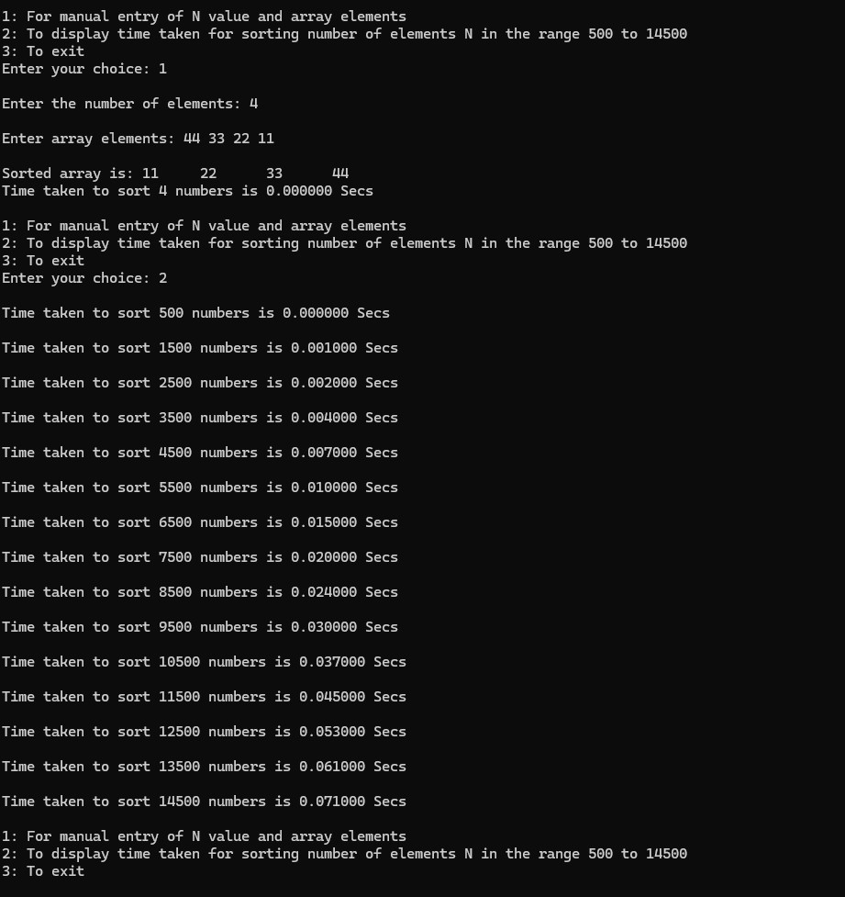

**GRAPH:**

